RESULTS

DATASET LINK
https://www.kaggle.com/datasets/thedevastator/toy-manufacturers-in-us- states?select=Week+39+-+US+Toy+Manufacturers+-+2005+to+2016.hyper

DASHBOARD LINK

https://public.tableau.com/app/profile/afrin.khatun.pathan/viz/AnalysisonnumberofManufacturerbyYear/Dashboard1%231

STORY LINK
https://public.tableau.com/app/profile/afrin.khatun.pathan/viz/AnalysisonnumberofManufacturerbyYear/Story1

PROFILE LINK

https://public.tableau.com/app/profile/afrin.khatun.pathan

SCREENSHOTS OF DASHBOARD AND STORY
DASHBOARD
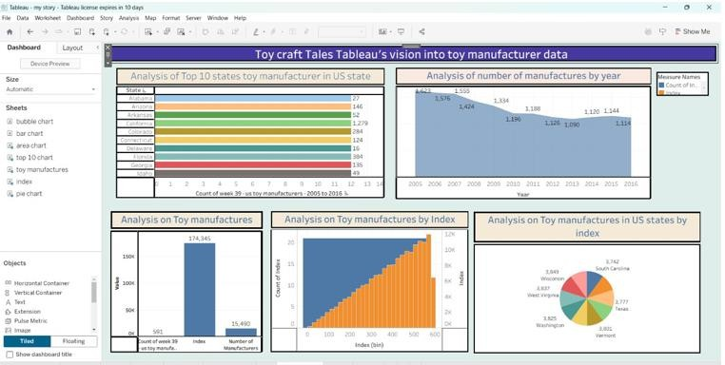

STORY
